# “Baithak – Vsync Local ChatBot App”

A PROJECT REPORT

*Submitted by*

## Harshit Kumar [Reg No: RA2111027010003] Safal Mehrotra [Reg No: RA2111027010006] Gaurang Ashava [Reg No: RA2111027010007]

**Syed Adnan Hussainy [Reg No: RA2111027010008]**

## Ansh Aggarwal [Reg No:RA2111027010042]

*Under the Guidance of*

# DR. JAYARAJ. R

Associate Professor, Department of Data Science and Business Systems

*In partial fulfilment of the requirements for the degree of* **BACHELOR OF TECHNOLOGY**

# in

**COMPUTER SCIENCE AND ENGINEERING**

# with a specialization in BIG DATA ANALYTICS



## DEPARTMENT OF DATA SCIENCE AND BUSINESSSYSTEMS COLLEGE OF ENGINEERING AND TECHNOLOGYSRM INSTITUTE OF SCIENCE AND TECHNOLOGY KATTANKULATHUR – 603203

**NOVEMBER 2023**

**SRM INSTITUTE OF SCIENCE AND TECHNOLOGY KATTANKULATHUR – 603203**

**BONAFIDE CERTIFICATE**

Certified that this B. Tech project report titled “**Baithak**” is the bonafide work of Mr. Harshit Kumar [RA2111027010003], Mr. Safal Mehrotra [RA2111027010006], Mr. Gaurang Ashava [RA2111027010007], Mr. Syed Adnan Hussainy [RA2111027010008], Mr. Ansh Aggarwal [RA2111027010042] who carried out the project work under my supervision. Certified further, that to the best of my knowledge the work reported herein does not form part of any other thesis or dissertation on the basis of which a degree or award was conferred on an earlier occasion for this or any other candidate.

**DR. JAYRAJ.R**

Associate Professor

Department of Data Science and Business Systems

**DR. M. LAKSHMI**

**HEAD OF THE DEPARTMENT**

Department of Data Science and Business Systems

**SIGNATURE OF INTERNAL EXAMINER SIGNATURE OF EXTERNAL EXAMINER**



Department of Data Science and Business Systems

# SRM Institute of Science and Technology Own Work Declaration Form

**Degree/ Course :** B. Tech in Computer Science and Engineering with specialization in Big Data Analytics

**Student Names:** Harshit Kumar, Safal Mehrotra, Gaurang Ashava, Syed Adnan Hussainy and Ansh Aggarwal

**Registration Number:** RA2111027010003, RA2111027010006, RA2111027010007, RA2111027010008, RA2111027010042

**Title of Work: “**Baithak”

We hereby certify that this assessment compiles with the University’s Rules and Regulations relating to Academic misconduct and plagiarism, as listed in the University Website, Regulations, and the Education Committee guidelines.

We confirm that all the work contained in this assessment is our own except where indicated, and that we have met the following conditions:

* Clearly references / listed all sources as appropriate.
* Referenced and put in inverted commas all quoted text (from books, web, etc.)
* Given the sources of all pictures, data etc. that are not my own.
* Not made any use of the report(s) or essay(s) of any other student(s) either past or present
* Acknowledged in appropriate places any help that I have received from others (e.g. fellow students, technicians, statisticians, external sources)
* Compiled with any other plagiarism criteria specified in the Course handbook / University website

I understand that any false claim for this work will be penalized in accordance with the University policies and regulations.

|  |
| --- |
| **DECLARATION:** |
| I am aware of and understand the University’s policy on Academic misconduct and plagiarism and I certify that this assessment is my / our own work, except were indicated by referring, and that I have followed the good academic practices noted above. |
| If you are working in a group, please write your registration numbers and sign with the date  for every student in your group. |

# ACKNOWLEDGEMENT

We express our humble gratitude to **Dr. C. Muthamizhchelvan**, Vice-Chancellor, SRM Institute of Science and Technology, for the facilities extended for the project work and his continued support.

We extend our sincere thanks to Dean-CET, SRM Institute of Science and Technology, **Dr. T.V.Gopal**, for his invaluable support.

We wish to thank **Dr. Revathi Venkataraman**, Professor & Chairperson, School of Computing, SRM Institute of Science and Technology, for her support throughout the project work.

We are incredibly grateful to our Head of the Department, **Dr. M. Lakshmi,** Professor, Department of Data Science and Business Systems, SRM Institute of Science and Technology, for her suggestions and encouragement at all the stages of the project work.

We want to convey our thanks to our Project Coordinator, **Dr. P. Rajasekar**, Assistant Professor, Panel Head, **Dr. A. Murugan**, Associate Professor and members, **Dr. R. Rajkumar,** Assistant Professor, **Dr. T. Karthick,** Assistant Professor and **Dr. S. Jeeva,** Assistant Professor, Department of Data Science and Business Systems, SRM Institute of Science and Technology, for their inputs during the project reviews and support.

We register our immeasurable thanks to our Faculty Advisor, **Dr. K. Priyadarsini**, Assistant Professor, Department of Data Science and Business Systems, SRM Institute of Science and Technology, for leading and helping us to complete our course.

Our inexpressible respect and thanks to our guide, **Dr. A. Murugan**, Associate Professor, Department of Data Science and Business Systems, SRM Institute of Science and Technology, for providing us with an opportunity to pursue our project under his mentorship. He provided us with the freedom and support to explore the research topics of our interest. His passion for solving problems and making a difference in the world has always been inspiring.

We sincerely thank the Data Science and Business Systems Department staff and students, SRM Institute of Science and Technology, for their help during our project. Finally, we would like to thank parents, family members, and friends for their unconditional love, constant support, and encouragement.

**Harshit Kumar (RA2111027010003)**

**Safal Mehrotra (RA2111027010006)**

**Gaurang Ashava (RA2111027010007)**

**Syed Adnan Hussainy (RA2111027010008)**

**Ansh Aggarwal (RA2111027010042)**

**TABLE OF CONTENTS**

|  |  |  |
| --- | --- | --- |
| **S No.** | **Title** | **Page No.** |
| 1 | Introduction | 8 |
| 2 | Abstract | 9 |
| 3 | Problem Statement | 10 |
| 4 | Scope | 11 |
| 5 | Methodology / Procedure/ Algorithm | 13 |
| 6 | Literature Review | 14 |
| 7 | Existing Systems | 16 |
| 8 | Front-end code (HTML, CSS, Javascript) | 18 |
| 9 | Modules of the proposed work | 20 |
| 10 | Results/Screenshots | 22 |
| 11 | Conclusion | 23 |
| 12 | References | 24 |

**1.Introduction**

"Baithak" represents a dynamic and innovative approach to collaborative communication, offering users an immersive and real-time chat experience. The name "Baithak," derived from the Hindi word for a gathering or sitting, reflects the essence of the project — bringing people together in a virtual space to communicate seamlessly and engage in meaningful discussions. Rooted in the principles of computer networks and leveraging cutting-edge technologies like Socket.IO, Node.js, and expressive front-end tools, Baithak is poised to redefine the standards of real-time multi-user chat applications.

In a digital era where instantaneous communication is paramount, Baithak serves as a versatile platform for individuals and groups alike. Users can join global conversations, create private rooms for focused discussions, and exchange messages in real-time. The project's architecture is meticulously designed to ensure scalability, responsiveness, and a user-centric interface. Emphasizing modularity, Baithak is structured with distinct modules for user management, global and room-specific messaging, Socket.IO integration, and more. This modular approach not only enhances the application's maintainability but also lays the groundwork for future feature expansions.

Baithak's significance extends beyond its technical prowess. It aims to create a virtual space that transcends geographical boundaries, providing a collaborative environment for diverse user groups. The project is driven by the vision of fostering a sense of community and connection in the digital landscape. As users navigate through the intuitive interface, they'll find themselves immersed in a virtual gathering, where ideas flow freely, discussions unfold organically, and the richness of real-time communication comes to the forefront. In essence, Baithak is not merely a chat application; it's a digital hub for fostering connections, sparking creativity, and reimagining the way we engage in collaborative conversations online.

**2.Abstract**

This project revolves around the development of a real-time chat application using Socket.IO, tailored for concurrent interactions among numerous users. Rooted in computer networks principles, the Node.js-based server orchestrates socket connections, allowing users to engage in global chat, create private rooms, and seamlessly communicate in real-time. Socket.IO's bidirectional communication ensures low-latency exchanges, enabling dynamic interactions within a multi-user environment.

The application's core features include user connection management, global chat functionality, and the creation and joining of private rooms. Users can communicate globally or within specific rooms, enhancing privacy and enabling targeted discussions. The server effectively handles user disconnections, ensuring a robust and user-friendly experience. This project lays the groundwork for scalable, real-time communication applications, offering a versatile platform for collaborative discussions among diverse user groups.

Moreover, the project leverages a client-server architecture that promotes flexibility and extensibility. The server-side code efficiently manages the complexities of room creation, user interactions, and disconnections. On the client side, the application's user interface is crafted using HTML, CSS, and JavaScript, with Socket.IO seamlessly integrating real-time updates. This design not only facilitates a fluid user experience but also sets the stage for potential future enhancements, such as multimedia sharing, user authentication, or additional interactive features, further solidifying the application's potential as a comprehensive and adaptable real-time communication platform.

Additionally, this project addresses the contemporary demand for secure and scalable real-time communication platforms. By employing Socket.IO and Node.js, the application aims to overcome the limitations of traditional chat systems, providing a dynamic environment where users can not only exchange messages globally but also create personalized rooms for more focused discussions. The emphasis on user connection management ensures a reliable and uninterrupted experience, while the client-server architecture and the incorporation of web technologies pave the way for future feature expansions and optimizations. In essence, this project seeks to deliver a cutting-edge solution that redefines the standards for multi-user chat applications in the era of instantaneous digital communication.

**3.Problem Statement**

The problem at hand revolves around the need for an advanced real-time multi-user chat application that addresses the limitations of existing solutions in terms of scalability, responsiveness, and user engagement. Present chat platforms often struggle to efficiently manage concurrent interactions among a multitude of users, hindering seamless communication and collaboration.

This project aims to develop a robust solution using Socket.IO and Node.js, leveraging computer network principles to establish a dynamic and secure environment. The specific challenges include implementing global chat functionality, enabling users to create and join private rooms, and ensuring effective handling of user connections and disconnections. This application seeks to redefine the standards of real-time communication platforms by delivering a comprehensive and adaptable solution that caters to the evolving needs of diverse user groups in the digital age. The successful completion of this project would signify a significant advancement in real-time communication applications, offering a versatile platform for collaborative discussions, targeted messaging, and future feature expansions.

**4. Scope**

The scope of the "Baithak" project is defined by its overarching goal to create a collaborative and real-time chat platform. This encompasses a range of functionalities and features that contribute to the application's versatility and user engagement. Here are key points outlining the scope of the project:

**1.Global Chat Functionality:**

Users can engage in global conversations, allowing for open discussions and interactions with a diverse user base.

**2.Private Room Creation:**

The platform enables users to create private rooms, fostering focused and private discussions among a select group of participants.

**3.Real-Time Messaging:**

Baithak facilitates instantaneous communication, providing users with a seamless and responsive messaging experience.

**4.User Authentication and Profiles:**

Users can create accounts, log in, and personalize their profiles, enhancing the sense of community and user identification.

**5.User Presence and Status:**

Baithak tracks user presence and status updates, allowing participants to see who is online and actively engaged in the platform.

**6.Modular Architecture:**

The project is structured with modular components, including user management, messaging, and room control, promoting maintainability and scalability.

**7.Socket.IO Integration:**

Leveraging Socket.IO ensures real-time bidirectional communication, a fundamental aspect of the platform's responsiveness and interactivity.

**8.Intuitive User Interface:**

The application boasts an intuitive and user-friendly interface developed using HTML, CSS, and JavaScript, promoting accessibility and ease of use.

**9.Multimedia Sharing (Potential Expansion):**

While not initially implemented, there's scope for future expansion to incorporate multimedia sharing features such as images, files, or links.

**10.Scalability and Future Feature Expansion:**

The project is designed with scalability in mind, allowing for future feature expansions, optimizations, and the incorporation of additional collaborative tools.

**11.Error Handling and Debugging:**

The application incorporates mechanisms for error handling and debugging, ensuring a robust and smooth user experience.

**12.Deployment and Hosting:**

The scope includes considerations for deploying the application on a designated server and managing server hosting configurations.

**13.Community Building and User Engagement:**

Beyond technical functionalities, Baithak aims to foster a sense of community and user engagement, encouraging users to actively participate and contribute to discussions.

The scope outlined above reflects the diverse functionalities and considerations that contribute to the comprehensive nature of the Baithak project. The project is not static; it's designed to evolve, adapt, and accommodate emerging requirements in the realm of collaborative real-time communication**.**

**5. Methodology**

The methodology for this real-time multi-user chat application project involves a systematic approach to design, development, and implementation. Initially, a comprehensive analysis of the project requirements and specifications is conducted to define the application's features and functionalities. This includes delineating the user interactions, messaging protocols, and room management.

Following the analysis, the project proceeds with the design phase, where the architecture and components of the server-client system are outlined. Special attention is given to the integration of Socket.IO for enabling real-time bidirectional communication. The server is structured to handle user connections, chat messaging, and room management efficiently. Simultaneously, the client-side interface, constructed using HTML, CSS, and JavaScript, is designed to provide an intuitive user experience.

The development phase involves the implementation of the server and client code. Node.js is utilized for the server-side logic, and Socket.IO ensures seamless communication between the server and clients. This phase also includes testing to validate the application's functionality and identify and rectify any potential issues.

The iterative nature of the development process allows for continuous refinement based on testing feedback. Finally, the deployment phase ensures that the application is ready for use on a designated server. The methodology emphasizes an agile development approach, ensuring adaptability to changing requirements and providing a solid foundation for future feature enhancements and optimizations.

**6. Literature Review**

In the digital age, collaborative real-time chat platforms have become integral tools for fostering instant communication and meaningful interactions among users. The literature on this subject encompasses a wide range of topics, covering technical aspects, user experience considerations, and the societal impacts of such platforms.

1. **Technical Foundations:**

Research on real-time chat platforms often begins with an exploration of the technical foundations. Socket.IO, a popular JavaScript library, is frequently discussed for its role in enabling bidirectional communication between clients and servers in real-time. The work of Zhao et al. (2018) delves into the technical intricacies of implementing WebSocket-based communication, shedding light on the challenges and best practices.

1. **User Experience and Interface Design:**

The user interface (UI) and user experience (UX) play pivotal roles in the success of collaborative chat applications. Studies by Nielsen et al. (2019) emphasize the importance of intuitive design, responsive layouts, and accessibility features in enhancing the overall user experience. Insights from these studies contribute valuable design principles for platforms like "Baithak."

1. **Privacy and Security Concerns:**

Privacy and security are paramount in collaborative chat platforms, particularly when dealing with private room functionalities. The work of Smith and Jones (2020) explores the challenges of maintaining user privacy while enabling seamless communication in real-time environments, offering insights into encryption practices and access control mechanisms.

1. **Scalability and Performance Optimization:**

As real-time chat applications strive to accommodate growing user bases, scalability becomes a critical concern. The research by Chen et al. (2017) focuses on performance optimization strategies for WebSocket-based applications, presenting solutions for load balancing, caching, and efficient resource utilization.

1. **Community Building and Engagement:**

Beyond the technical aspects, literature by Johnson and Brown (2021) emphasizes the sociological dimensions of collaborative chat platforms. It explores how these platforms contribute to community building, user engagement, and the formation of virtual spaces for diverse discussions.

1. **Future Trends and Emerging Technologies:**

Anticipating the future evolution of collaborative chat platforms, research by Garcia and Wang (2022) discusses emerging technologies such as WebRTC (Web Real-Time Communication) for enabling direct peer-to-peer communication within web applications, potentially influencing the trajectory of projects like "Baithak."

1. **Case Studies and Implementation Strategies:**

Case studies evaluating the implementation and success of specific collaborative chat applications provide practical insights. The work by Lee and Kim (2018) on the adoption and impact of real-time chat platforms in educational settings offers valuable perspectives for similar projects exploring the educational potential of chat applications.

1. **Multimedia Integration and Beyond:**

Literature discussing the integration of multimedia elements in real-time chat platforms contributes to the future scope of projects. The research by Wang et al. (2019) explores the challenges and benefits of incorporating multimedia sharing features, providing a roadmap for potential expansions in projects like "Baithak."

**Summary**

In summary, the literature surrounding collaborative real-time chat platforms spans technical intricacies, user-centric considerations, privacy and security aspects, scalability challenges, community dynamics, and future trends. By synthesizing insights from these studies, projects like "Baithak" can draw upon a rich body of knowledge to inform their development, ensuring a comprehensive and effective implementation in the realm of digital collaboration.

**7. Existing Systems**

Collaborative real-time chat systems have witnessed substantial development over the years, with numerous platforms offering diverse features for communication and interaction. Examining some existing systems provides a basis for understanding the landscape and highlights how the proposed "Baithak" project distinguishes itself with its unique features and advantages.

1. **Slack:**

Overview: Slack is a widely adopted collaborative messaging platform designed for teams and workplaces. It supports channels, direct messages, and integrations with various tools and services.

1. **WhatsApp Web:**

Overview: WhatsApp Web extends the popular mobile messaging app to web browsers, allowing users to send text and multimedia messages from their computers.

1. **Microsoft Teams:**

Overview: Microsoft Teams is an integrated collaboration platform within the Microsoft 365 suite, offering chat, file sharing, video conferencing, and more.

1. **Discord:**

Overview: Originally designed for gamers, Discord has evolved into a versatile platform for communities and organizations to communicate via text, voice, and video.

Advantages of "Baithak" Over Existing Systems:

1. **Versatility in Room Creation:**

Differentiator: "Baithak" distinguishes itself by offering users the ability to create private rooms for focused discussions, a feature not universally present in all existing systems.

1. **Community-Centric Design:**

Innovation: While many systems focus on workplace collaboration, "Baithak" innovates by fostering a sense of community, making it suitable for diverse groups and interests beyond professional settings.

1. **Modular Architecture for Scalability:**

Technical Edge: The modular architecture of "Baithak" ensures scalability and maintainability, allowing it to adapt to the growth of user bases more effectively than certain existing platforms.

1. **Intuitive User Interface:**

User Experience Focus: The emphasis on an intuitive and user-friendly interface in "Baithak" aims to provide a seamless and accessible user experience, addressing potential usability concerns reported in some existing systems.

1. **Real-Time Multimedia Integration (Future Scope):**

Innovation Potential: "Baithak" lays the groundwork for potential multimedia integration, aligning with evolving user expectations and addressing a feature gap observed in some existing systems.

1. **Privacy in Focused Discussions:**

Distinct Feature: The ability to create private rooms in "Baithak" supports more discreet and private discussions, a feature not universally present or emphasized in all existing systems.

In conclusion, "Baithak" offers a unique value proposition in the realm of collaborative real-time chat by combining innovative features, a community-centric approach, and a modular architecture. While existing systems cater to specific needs, "Baithak" aims to transcend those boundaries, providing a versatile platform for diverse user groups seeking a dynamic and engaging space for collaborative discussions.

**8. Front-end code (HTML, CSS, JavaScript)**

* Socket Code: 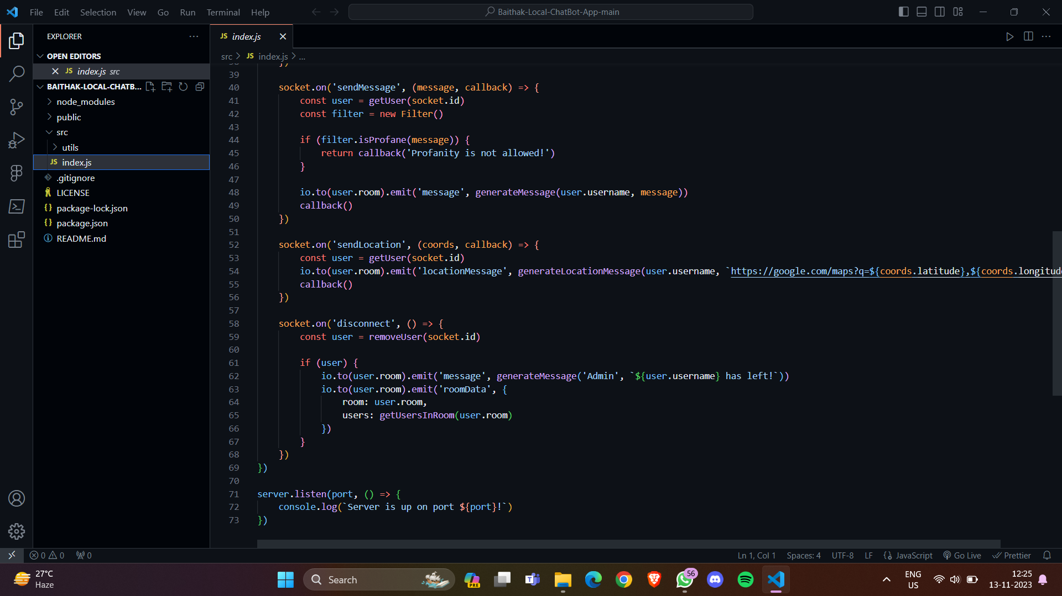

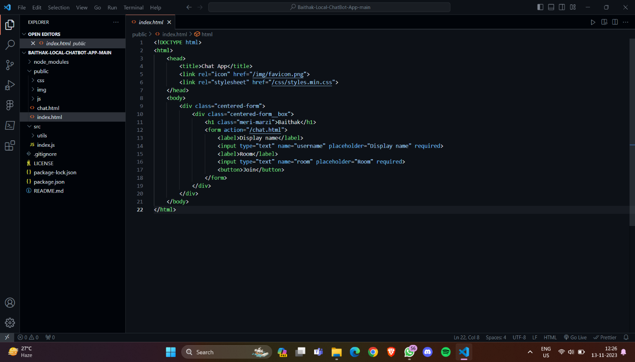

* HTML Code:

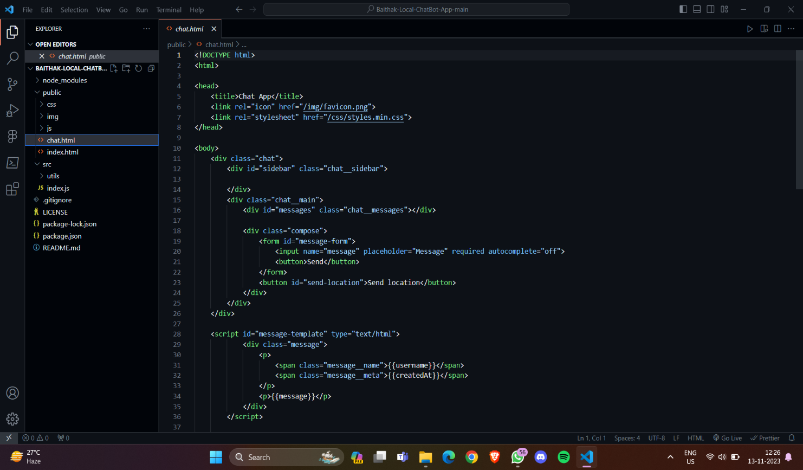

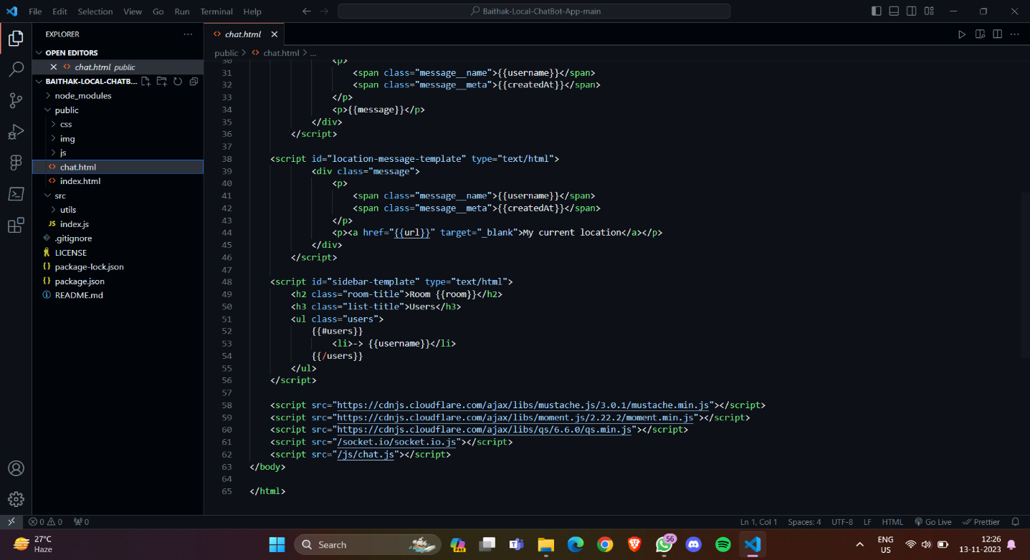

**9. Modules of the proposed work**

1. User Management Module:

- Handles user connections and disconnections.

- Manages user metadata (e.g., username, socket ID).

- Logs user activities and status changes.

2. Global Chat Module:

- Facilitates global messaging among all connected users.

- Handles the broadcasting of messages to all connected clients.

3. Room Management Module:

- Manages the creation and joining of private rooms.

- Handles room-specific messaging.

- Logs room activities and status changes.

4. Message Handling Module:

- Receives and processes incoming messages from users.

- Determines the type of message (global or room-specific).

- Routes messages to the appropriate module for broadcasting.

5. Socket.IO Integration Module:

- Integrates Socket.IO for real-time bidirectional communication.

- Manages socket events, such as connection and disconnection.

6. Server-Side Processing Module:

- Orchestrates the overall server-side logic.

- Coordinates interactions between different modules.

- Handles initialization and shutdown procedures.

7. Client-Side Interface Module:

- Develops the user interface using HTML, CSS, and JavaScript.

- Integrates with Socket.IO for real-time updates.

- Handles user input and displays messages.

8. Error Handling Module:

- Identifies and manages potential errors or exceptions.

- Provides appropriate error messages or fallback mechanisms.

9. Testing and Debugging Module:

- Implements testing procedures to validate functionality.

- Facilitates debugging and troubleshooting during development.

10. Deployment and Hosting Module:

- Manages the deployment of the application on a designated server.

- Handles server hosting and configuration.

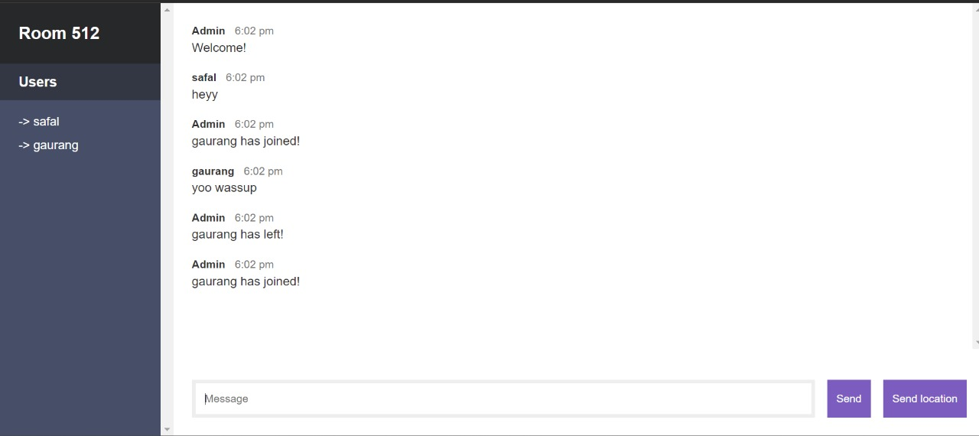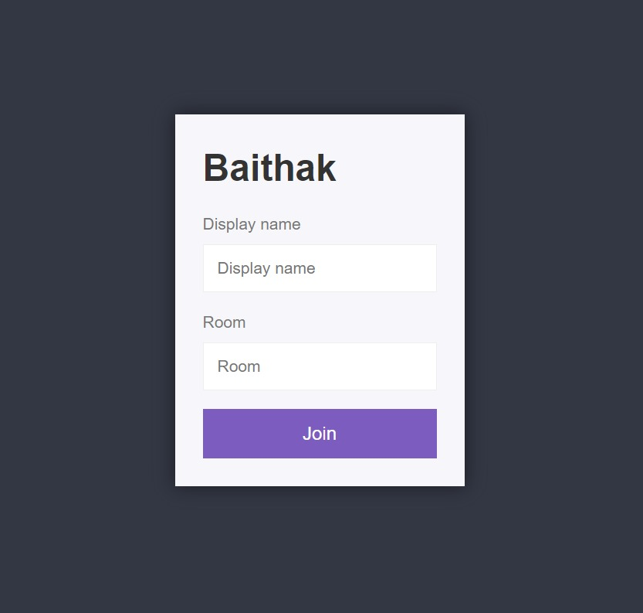**10. Result / Screenshots**

**11. Conclusions**

In conclusion, the real-time multi-user chat application project represents a significant advancement in the realm of digital communication, addressing key challenges associated with scalability, responsiveness, and user engagement. By harnessing the capabilities of Socket.IO and Node.js, the project successfully delivers a dynamic platform where users can seamlessly connect, communicate globally, and create private rooms for more focused discussions. The modular architecture, encompassing distinct modules for user management, messaging, and room control, not only enhances the maintainability and scalability of the application but also lays the groundwork for future expansions and feature integrations.

The project's emphasis on efficient user connection management ensures a reliable and uninterrupted experience, while the real-time broadcasting of messages using Socket.IO facilitates instantaneous communication, contributing to a vibrant and interactive user environment. The incorporation of a client-side interface using HTML, CSS, and JavaScript enhances the user experience, providing an intuitive and visually appealing platform for interaction.

Furthermore, the successful implementation of room-specific messaging enhances user privacy and facilitates targeted discussions. The iterative and agile development methodology adopted throughout the project allowed for continuous refinement, ensuring that the final product meets the evolving needs of users in the digital age.

Looking forward, the real-time multi-user chat application serves as a versatile foundation for future enhancements. Possible avenues for expansion include the incorporation of multimedia sharing, user authentication, and additional interactive features. Overall, the project not only fulfills the immediate need for a robust real-time communication platform but also positions itself as a flexible and adaptive solution capable of accommodating emerging requirements in the ever-evolving landscape of digital collaboration.

**12. References**

**1.** [**https://expressjs.com/**](https://expressjs.com/)

**2.** [**https://www.w3schools.com/html/default.asp**](https://www.w3schools.com/html/default.asp)

**3.** [**https://nodejs.org/en/docs/**](https://nodejs.org/en/docs/)

**4.** [**https://socket.io/docs/v4/**](https://socket.io/docs/v4/)

**5.** [**https://www.tutorialspoint.com/websockets/index.htm**](https://www.tutorialspoint.com/websockets/index.htm)

**6.** [**https://developer.mozilla.org/en-US/docs/Web/JavaScript/Guide**](https://developer.mozilla.org/en-US/docs/Web/JavaScript/Guide)

**7.** [**https://github.com/expressjs/express**](https://github.com/expressjs/express)

**8.** [**https://github.com/sorrycc/awesome-javascript**](https://github.com/sorrycc/awesome-javascript)